A Project Report

on

Speech Emotion Recognition System

carried out as part of the Minor Project IT3270 Submitted

by

Dev Beniwal
209302060

in partial fulfilment for the award of the degree of

Bachelor of Technology

in

Information Technology

Under the Guidance of
Guide Name



School of Information Technology
Department of Information Technology

MANIPAL UNIVERSITY JAIPUR
RAJASTHAN, INDIA

April 2023

CERTIFICATE

Date: 21-4-23

This is to certify that the minor project titled Speech Emotion Recognition System is a record of the bonafide work done by Dev Beniwal (209302060) submitted in partial fulfilment of the requirements for the award of the Degree of Bachelor of Technology in Information Technology of Manipal University Jaipur, during the academic year 2022-23.

Ms. Neha V Sharma
Assistant Professor

Project Guide, Department of Information Technology

Manipal University Jaipur

Dr. Pankaj Vyas

HoD, Department of Information Technology
Manipal University Jaipur

ABSTRACT

The speech emotion recognition is a very interesting yet vert challenging task of human
computer interaction. In the recent years this topic has grabbed so much attention. In the field of
speech emotion recognition many techniques have been utilized to extract emotions from signals,
including many well-established speech analysis and classification techniques. In the traditional
way of speech emotion recognition features are extracted from the speech signals and then the
features are selected which is collectively know as selection module and then the emotions are
recognized this is a very lengthy and time taking process so this paper gives an overview of the
deep learning technique which is based on a simple algorithm based on feature extraction and
model creation which recognizes the emotion.

The rest of the article is organized as follows 1) Introduction, 2)Literature Review, 3) Design Flow \ Process, 4) Result, 5) Conclusion\Future work, 6) Reference.

LIST OF FIGURES

Figure No | Figure Title | Page No
1 | Traditional Representation of SER | 8
2 | Designing of SER | 10
3 | Imported libraries | 11
4 | Function of data label and its path | 11
5 | Creation of Dataframe | 12
6 | Plotting the data | 12
7 | Graphical representation of data | 12
8 | MFCC specification code | 13
9 | Extracting MFCC Features | 13
10 | Labelling the emotions | 13
11 | LSTM model Initiation | 14
12 | Output of LSTM model | 15
13 | Training the model | 15
14 | Testing accuracy | 15
15 | Code to plot the accuracy of the model | 16
16 | Output of Accuracy of Model | 16
17 | Code for plotting the loss | 17
18 | Output of Loss accuracy | 17
19 | Outputs for testing | 17
20 | Code for Plotting Confusion Matrix | 18
21 | Confusion Matrix | 18

Content no. | Content ID | Content Type | Content | Page no.
1 |  | Paragraph | Abstract | 3
2 | 1 | Main Heading | Introduction | 6
3 | 1.1 | Sub Heading | Overview | 6
4 | 1.2 | Sub Heading | Problem Statement | 6
5 | 1.3 | Sub Heading | Objectives | 6
6 | 1.4 | Sub Heading | Scope Of project | 6
7 | 2 | Main Heading | Background Detail | 7
8 | 2.1 | Sub Heading | Literature Review | 7
9 | 2.2 | Sub Heading | Other Methodologies | 8
10 | 3 | Main Heading | Methodology | 10
11 | 3.1 | Sub Heading | Loading the Dataset | 11
12 | 3.2 | Sub Heading | Feature Extraction | 13
13 | 3.3 | Sub Heading | Implementing the model | 14
14 | 3.4 | Sub Heading | Training the Model | 15
15 | 3.5 | Sub Heading | Emotions Recognized | 15
16 | 4 | Main Heading | Result Analysis | 16
17 | 5 | Main Heading | Conclusion And Future Work | 19
18 | 5.1 | Sub Heading | Conclusion | 19
19 | 5.2 | Sub Heading | Future Work | 19
20 | 6 | Main Heading | References | 20
Table of Contents

- INTRODUCTION

Emotions are an integral part of human communication, and they can be conveyed through various modalities, including speech. Speech emotion recognition (SER) has gained significant attention in recent years as a research area in machine learning and artificial intelligence.

SER systems can be used to develop intelligent human-computer interfaces, improve mental health diagnosis, and enhance human-robot interaction, among other applications. In this project report, I present a detailed study of a speech emotion recognition system that utilizes machine learning models to recognize emotional states from speech signals. My study includes a comprehensive analysis of the state-of-the-art methods for SER, an overview of the dataset used for training and evaluation, a description of the feature extraction techniques and the machine learning models employed, and an evaluation of the performance of the proposed system.

The main objective of this project is to develop an accurate and reliable SER system that can classify speech signals into various emotional states. This report will provide a detailed account of our approach, results, and insights gained from our study, and it will serve as a useful resource for researchers and practitioners working in the field of SER.

  - Overview

Speech Emotion Recognition (SER) is a new research aiming to develop a computational model that can recognize emotions in speech. The ability to recognize emotions in speech has many applications in areas such as human-computer interaction, technology, and psychotherapy. In recent years, due to the proliferation of big speech data and advances in machine learning, the development of the SER machine learning model has received a lot of attention. In this report, we present research on SER systems that use machine learning models to recognize emotions without speech.

1.2 Problem Statement

This problem solver is for constructing an accurate and reliable knowledge of machine thinking using the learning model. The main goal is to create a system that can correctly classify speech according to different emotions.

1.3 Objectives
The objectives of this project are:

• Review the existing literature on speech recognition and machine learning models.
• Gather and prepare necessary documents for review of the training and planning process.
• Extracting distracting features from speech characters and building machine learning models for classification.
• Evaluate the performance of the proposed method using various metrics and compare it with existing methods in the literature.

1.4 Project Scope
This project focuses on improving speech recognition using machine learning.
This work includes various stages of development, including data collection and preprocessing, feature extraction, machine learning models, and performance evaluation. The effectiveness of the method is compared with existing methods in the literature and the insights gained from the research are discussed.

- BACKGROUND DETAIL

2.1 Conceptual Overview/Literature Review
Speech is the way people communicate, and the thoughts expressed through speech play an important role in communicating desired information. Speech recognition aims to use methods to analyze emotions in speech. In recent years, the development of SER systems has received great attention due to their wide application in human-computer science, technology, and clinical psychology. Various approaches have been proposed in the literature on SER, including acoustic-based, language-based, and hybrid approaches. Machine learning models, including support vector machines, decision trees, neural networks, and deep learning models, are widely used in SER.

Over the last years a lot of researches have been made to extract the emotion of human speech some of the studies include:
- s. Cao et al. [1] proposed a ranking SVM method for synthesize information about emotion recognition to solve the problem of binary classification.
- Chen et al. [2] aimed to improve speech emotion recognition in speaker-independent with three level speech emotion recognition method.
- Nwe et al. [3] proposed a new system for emotion classification of utterance signals. The system employed a short time log frequency power coefficients (LFPC) and discrete HMM to characterize the speech signals and classifier respectively.
- T Wu et al. [4] proposed a new modulation spectral features (MSFs) human speech emotion recognition.
- Rong et al. [5] presented an ensemble random forest to trees (ERFTrees) method with a high number of features for emotion recognition without referring any language or linguistic information remains an unclosed problem.
- Wu et al. [6] proposed a fusion-based method for speech emotion recognition by employing multiple classifier and acoustic-prosodic (AP) features and semantic labels (SLs).
- Narayanan [7] proposed domain-specific emotion recognition by utilizing speech signals from call center application. Detecting negative and non-negative emotion (e.g. anger and happy) are the main focus of this research.
- Yang & Lugger [8] presented a novel set of harmony features for speech emotion recognition. These features are relying on psychoacoustic perception from music theory.
- Albornoz et al. [9] investigate a new spectral feature in order to determine emotions and to characterize groups.
- Lee et al. [10] represent a hierarchical computational structure to identify emotions. Lee et al. [11-12] proposed hierarchical structure for binary decision tree in emotion recognition fields.
- Yeh et al. [13] proposed a segment based method for recognition of emotion in Mandarin speech. 6 Downloaded by Dev Beniwal (devbeniwal426@gmail.com) lOMoARcPSD|24621084
- Dai et al. [14] proposed a computational approach for recognition of emotion and analysis the specifications of emotion in voiced social media such as WeChatt.
- El Ayadi et al. [15] proposed a Gaussian mixture vector autoregressive (GMVAR) approach, which is mixture of GMM with vector autoregressive for classification problem of speech emotion recognition.
- Arias et al. [16] proposed a novel shape based method by using neutral model to recognize emotional salience in the basic frequency.
- Grimm et al. [17] proposed a multi-dimensional model by utilizing emotion primitives for speech emotion recognition.

An emotion recognition system based on digitized speech is comprised of three fundamental components signal preprocessing feature extraction and classification [25]. Acoustic preprocessing such as denoising as well as segmentation is carried out to determine meaningful units of this signal [ 26]. feature extraction is utilized to identify the rare event feature available in the signal. Lastly, the mapping of extracted feature vectors to relevant emotion is carried out by classifiers. In this section, a detailed discussion of speech signal processing, feature extraction, and classification is provided [27] Also, the differences between spontaneous and acted speech are discussed due to their relevance to the topic [28], [29]. Figure 1 depicts a simplified system utilized for speech-based emotion recognition. In the first stage of speech based signal processing, speech enhancement is carried out where the noisy components are removed. The second stage involves two parts, feature extraction, an feature selection. The required features are extracted from the preprocessed speech signal and the selection is made from
the extracted features. Such feature extraction and selection are usually based on the analysis of speech signals in the time and frequency domains. During the third stage, various classifiers such as GM Mand HMM, etc. are utilized for the classification of these features. Lastly, based on feature classification different emotions are recognized.
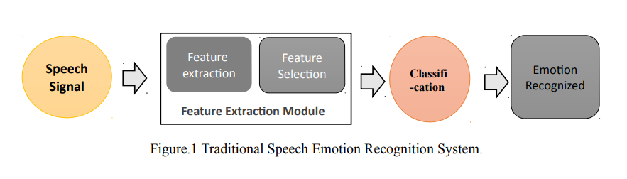

2.2 Other Software Engineering Methodologies (if applicable)

This project follows the software development process, including analysis, design, implementation, testing and maintenance. The process includes collecting and preprocessing data, removing relevant features, building machine learning models, and evaluating the effectiveness of the proposal. Software development techniques include programming languages such as Python and machine learning using libraries such as Scikitlearn and TensorFlow. Evaluation of the proposed system will involve the use of various criteria such as accuracy, precision, recall, F1 score and confusion matrix.

Speech processing usually functions in a straightforward manner on an audio signal [30]. It is considered significant and necessary for various speech-based applications such as SER, speech denoising, and music classification. With recent advancements, SER has gained much significance. However, it still requires accurate methodologies to mimic human-like behavior for interaction with human beings [31]. As discussed earlier, an SER system is made up of various components that include feature selection and extraction, feature classification, acoustic modeling, recognition per unit, and most importantly language-based modeling. The traditional SER systems typically incorporate various classification models such as GMMs and HMMs. The GMMs are utilized for illustration of acoustic features of sound units, while, the HMMs are utilized for dealing with temporal variations occurrence in speech signals. Deep learning methods are comprised of various nonlinear components that perform computation on a parallel basis [32]. However, these methods need to be structured with deeper layers of architecture to overcome the limitations of other techniques. Deep learning techniques such as Deep Boltzmann Machine (DBM), Recurrent Neural Network (RNN), Recursive Neural Network (RNN), Deep Belief Network (DBN), Convolutional Neural Networks (CNN) and Auto Encoder (AE) are considered a few of the fundamental deep learning techniques used for SER, that significantly improves the overall performance of the designed system.

With the advancement in this field the possible advantages of this have started to increase some of the possible advantages of this technique is:
1. Education: a course system for distance education can detect bored users so that they can change the style or level of the material provided in addition, to provide emotional incentives or compromises. [19]
2. Automobile: driving performance and the emotional state of the driver are often linked internally. Therefore, these systems can be used to promote the driving experience and to improve driving performance. [19]
3. Security: They can be used as support systems in public spaces by detecting extreme feelings such as fear and anxiety. [19]
4. Communication: in call centres, when the automatic emotion recognition system is integrated with the interactive voice response system, it can help improve customer service. [19]
5. Health: It can be beneficial for people with autism who can use portable devices to understand their own feelings and emotions and possibly adjust their social behaviour accordingly. [18]
6. Promotion: In the promotional calls or any type of promotional work this technique can be used to determine the emotion of the other person and change his strategy accordingly.
7. Customer True Review: when the automatic emotion system is integrated an honest review of the consumer can be detected easily which can further lead a business to new heights.

In the next sections of the report, I will present the methodology used for the development of the proposed speech emotion recognition system, including data collection, feature extraction, and machine learning models. We will also present the results and analysis of the proposed system and compare its performance with existing methods from the literature. Finally, I will discuss the insights gained from the study and provide suggestions for future research in the field of speech emotion recognition.

- METHODOLOGY

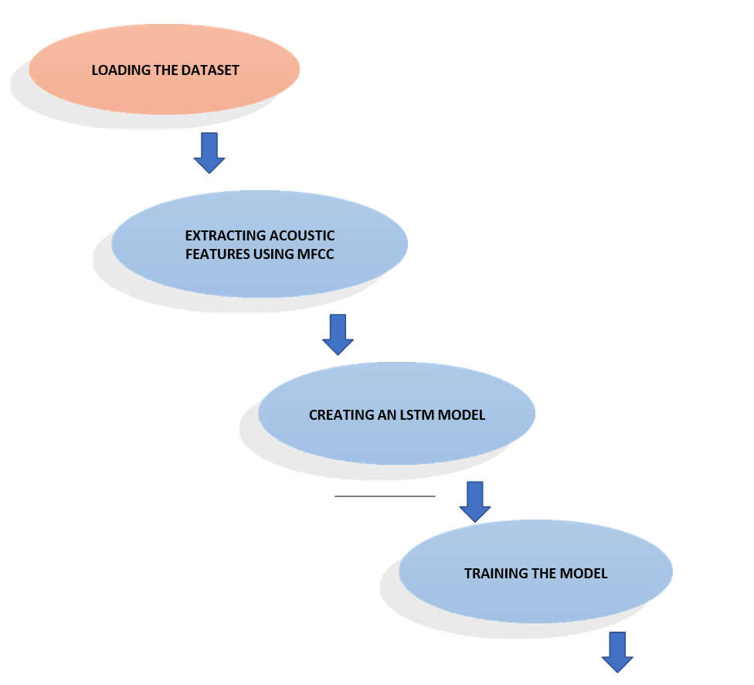
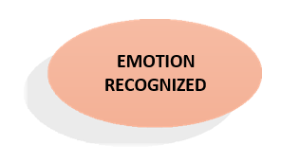

Figure 2: Designing of the SER

3.1 Loading the Dataset
There are set of 200 target words were spoken in the carrier phrase "Say the word 'by two actresses (aged 26 and 64 years) and recordings were made of the set portraying each of seven emotions (anger, disgust, fear, happiness, pleasant surprise, sadness, and neutral). There are 2800 data points (audio files) in total.
The dataset is organized such that each of the two female actor and their emotions are contain within its own folder. And within that, all 200 target words audio file can be found. The format of the audio file is in WAV format.
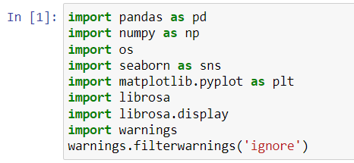
Figure 3: Imported libraries

First of all we have imported some libraries:
The first five i.e pandas, numpy, os, seaborn, and matplotlib are for visualization purpose. Now to import the audio files we have used the Librosa and Librosa.display.
if you want to play the audio means we have to import the ipython.display,import audio To ignore the warnings we are using warnings.filterwarnings(‘ignore’)

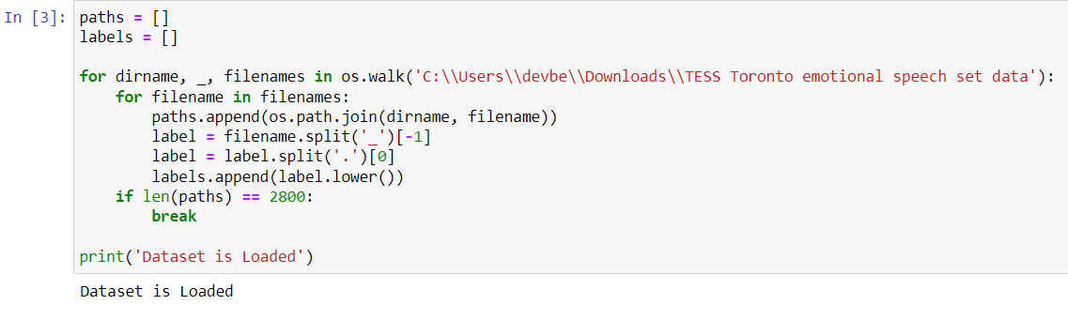
Figure.4 Function of data label and its path

The file paths and labels are loaded from the TESS dataset. The code loops through the directory tree using os.walk() and appends the file paths and labels to two lists. The if statement ensures that only the first 2800 files are loaded.

Using paths and labels we have created two lists and by these lists we will create dataframe by adding everything into the list.

Label.append will move the labels to the label list



Figure.5 Creation of Dataframe

Here we have created a data frame for paths and labels.
The total no samples use for each emotion i.e fear, anger ,disgust, neutral, sad, ps ,and happy are
400. Total 2800 samples.
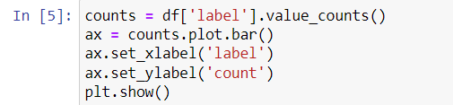
Figure.6 Plotting the data

The label counts are plotted using the Pandas value_counts() method and the plot.bar() function from matplotlib.

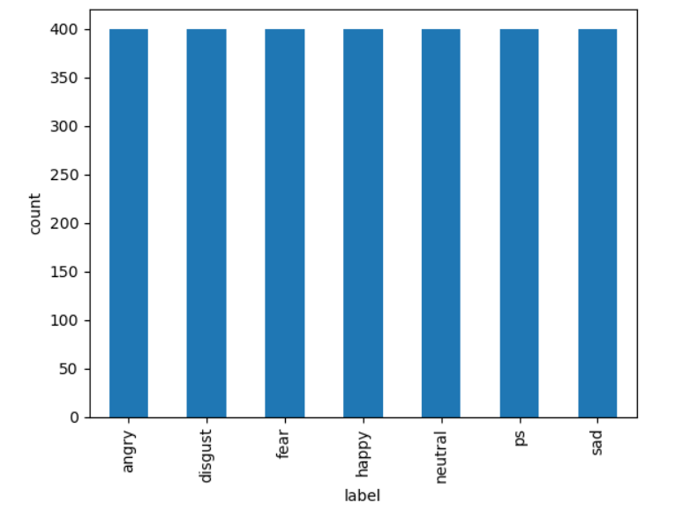
Figure.7 Graphical representation of data

Here is the output of the data in a graphical representation.

3.2 Feature extraction:

Feature extraction is the process of extracting various acoustic features of the speech which can directly affect the accuracy of the classification results, acoustic features include physical aspects of spoken language that can be recorded and analyzed these include waveform analysis, FFT or LPC analysis, voice onset time , format frequency, measurements and so on.
For the feature extraction purpose various methods are used such as MFCC, LPC, LPCC, LSF, PLP, DWT. We are using the MFCC method in our model for the process of feature extraction.

So Mel Frequency Cepstral Coefficient ( MFCC ) is basically one of the methods used to extract the various acoustic features of a speech from a raw data to perform various things on the extracted data which can be further used for the classification of the emotions of a speech.

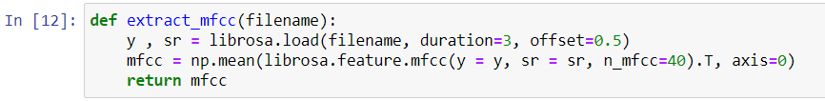
Figure.8 MFCC specification code

A function called extract_mfcc() is defined to extract MFCC (Mel-frequency cepstral coefficients) features from an audio file. It loads an audio file using librosa.load(), then extracts the MFCCs using librosa.feature.mfcc() and takes the mean across the time axis.

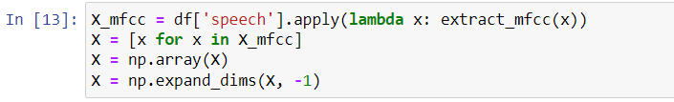
Figure.9 Extracting MFCC Features

The MFCC features are extracted from all the audio files in the dataframe using apply() and the extract_mfcc() function. The resulting MFCC arrays are appended to a list, which is then converted to a NumPy array of shape (2800, 40). The array is then expanded along a new dimension using np.expand_dims(), resulting in a final shape of (2800, 40, 1).

Figure.10 Labelling the emotions

The labels are converted from strings to integers using a dictionary called label_dict. The integers are then converted to one-hot encoded arrays using np.eye().

3.3 Implementing the Model
For creating the LSTM model we have to import the sequential, dense, LSTM and the dropout form keras.models and keras.layers respectively.
Then specifying the various values required.

In the next step compiling the model for loss and accuracy and then model.summary() to view the model it will look something like this.

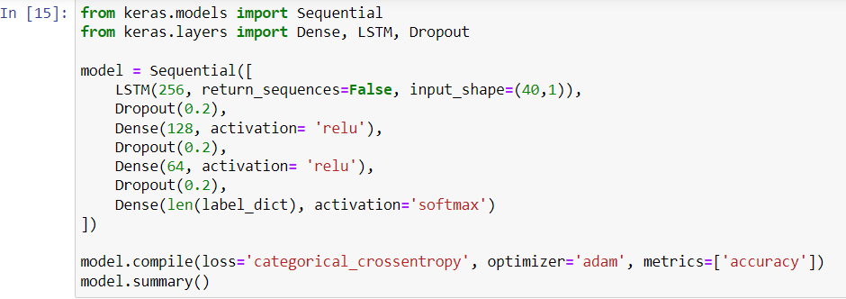
Figure.11 LSTM model Initiation

A LSTM model is defined using the Keras Sequential API. It consists of four layers: an LSTM layer with 256 units, a dropout layer with a rate of 0.2, a dense layer with 128 units and ReLU activation, another dropout layer, a dense layer with 64 units and ReLU activation, another dropout layer, and a final dense layer with softmax activation to output the probabilities of the different classes. The model is compiled using categorical cross-entropy loss, the Adam optimizer, and accuracy as the metric.

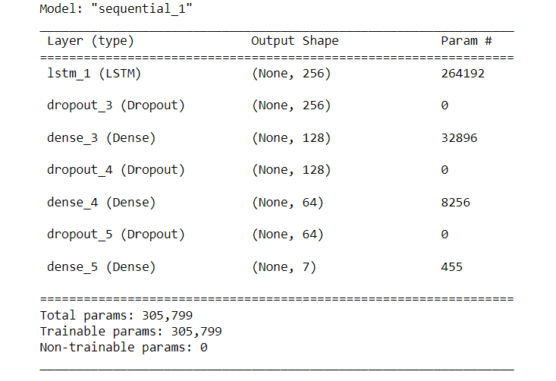
Figure.12 Output of LSTM model

3.4 Training the model
Figure.13 Training the model

Validation split = it will do the splitting for us.
Epochs = the number of complete passes through the complete dataset. Batch size= the number of training examples utilized in one literaion.

3.5 Emotion Recognized
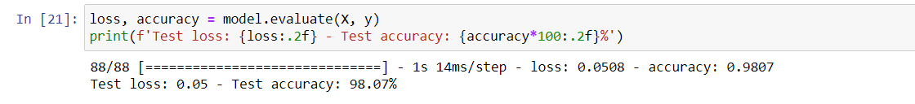
Figure 14. Testing accuracy

As we can see from this screenshot my model recognized the testing dataset at the accuracy of 98.07%.

A detailed explanation will be given in the next section below.

- RESULT ANALYSIS

Using the matplotlib library we have visualized the accuracy and loss of the model.

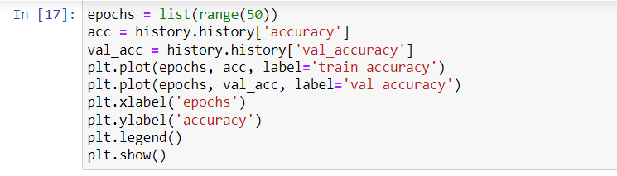
Figure.15 Code to plot the accuracy of the model
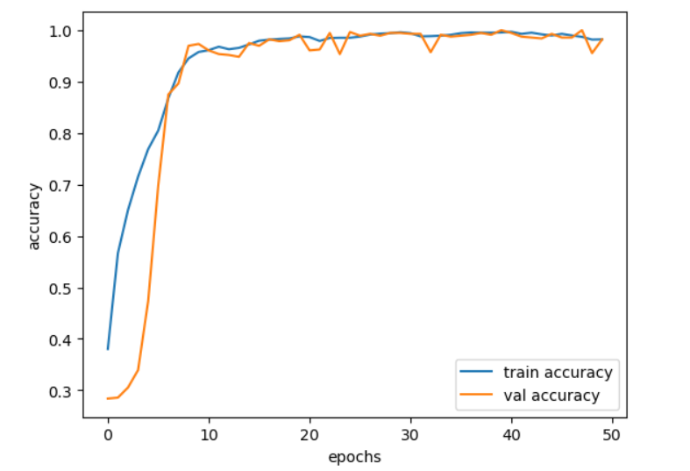
Figure.16 Output of Accuracy of Model

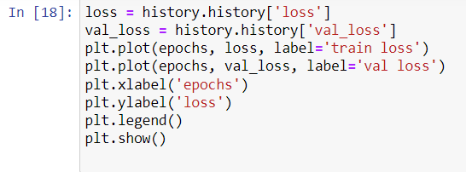
Figure.17 Code for plotting the loss
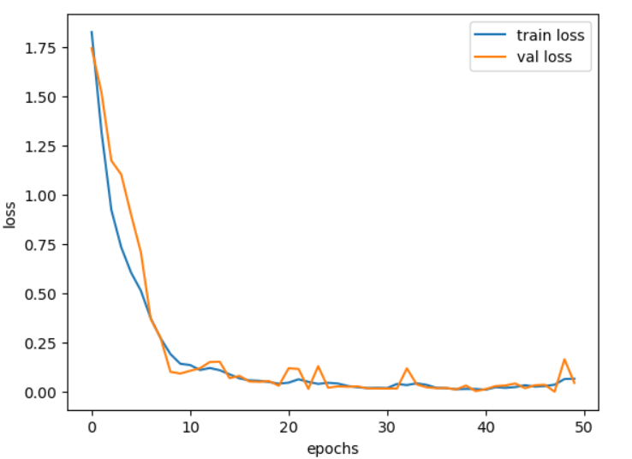
Figure.18 Output of Loss accuracy

We have tried running the model by giving different data and the result obtained is as follows:
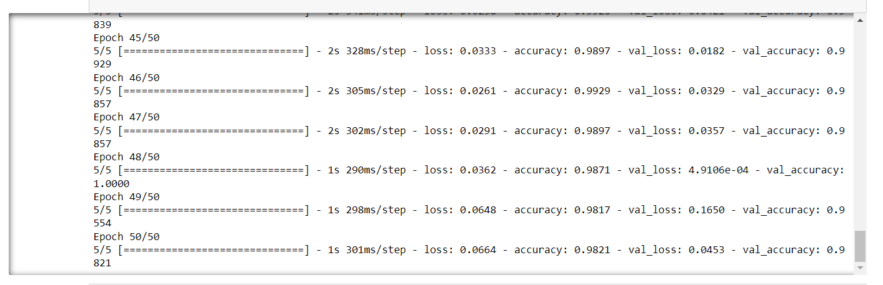
Figure.19 Outputs for testing

So in this model after analyzing 2800 samples of data using the MFCC method of feature extraction and through the LSTM model for training and testing purposes we have got the accuracy of the model of about 97 percent and value loss of around 3 percent.
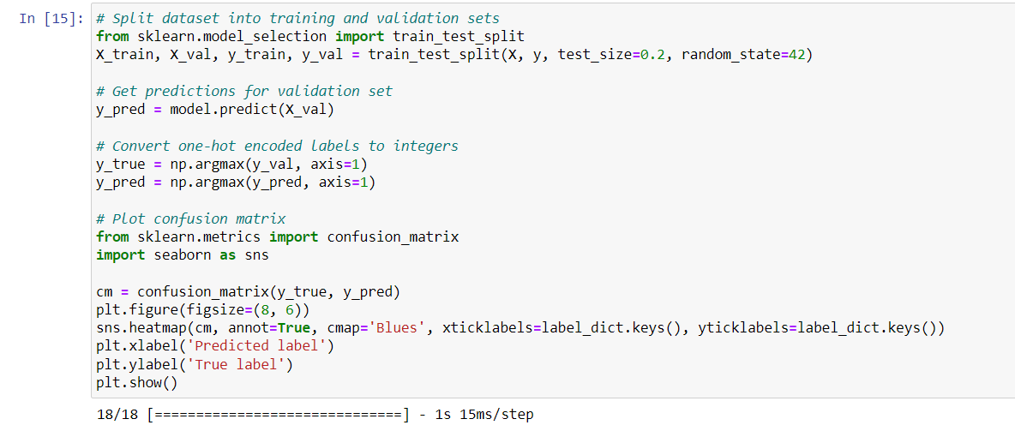
Figure.20 Code to plot the confusion matrix
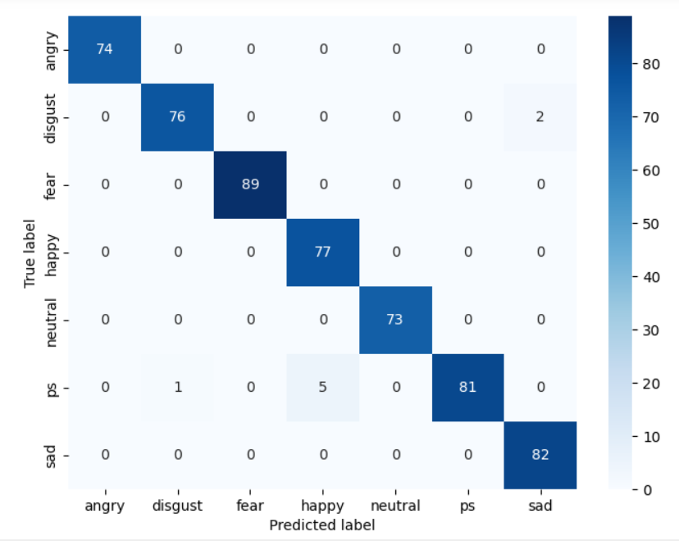
Figure.21 Confusion matrix for the emotions

- CONCLUSION AND FUTURE WORK

5.1 Conclusion
In this project we have tried to analyze some samples of speech using the deep learning technique. Firstly we loaded the datasets then we visualized the different human emotions using our functions waveshow and spectrogram using the Librosa library. Then we extracted the acoustic features of all our samples using the MFCC method and arranged the sequential data obtained in the 3D array form as accepted by the LSTM model. Then we build the LSTM model and after training the model.
I visualized the data into the graphical form using matplotlib library and after some repeated testing using different values the average accuracy of the model is found to be 98%.

5.2 Future work

So the speech emotion recognition is a very interesting topic and there is lot more to discover in the field, in our model the future work will include the improvement of accuracy of the model to get better results, we can also train the model to give results of the speech that is longer in duration like in this model we are able to recognize the emotion only for short duration of time in future we will able to load the longer sample dataset and the model the model will classify different emotions in different period of time. Its future work can also include the recording of on time data through a microphone so that there is no need of loading the dataset we will just train the model and then data can be recorded to give the emotions of that person’s voice.

REFERENCES

1.)H. Cao, R. Verma, and A. Nenkova, “Speaker-sensitive emotion recognition via ranking: Studies on acted and spontaneous speech,” Comput. Speech Lang., vol. 28, no. 1, pp. 186– 202, Jan. 2015.

2.)L. Chen, X. Mao, Y. Xue, and L. L. Cheng, “Speech emotion recognition: Features and classification models,” Digit. Signal Process., vol. 22, no. 6, pp. 1154–1160, Dec. 2012

3.)T. L. Nwe, S. W. Foo, and L. C. De Silva, “Speech emotion recognition using hidden Markov models,” Speech Commun., vol. 41, no. 4, pp. 603–623, Nov. 2003.

4.)S. Wu, T. H. Falk, and W.-Y. Chan, “Automatic speech emotion recognition using modulation spectral features,” Speech Commun., vol. 53, no. 5, pp. 768–785, May 2011.

5.)J. Rong, G. Li, and Y.-P. P. Chen, “Acoustic feature selection for automatic emotion recognition from speech,” Inf. Process. Manag., vol. 45, no. 3, pp. 315–328, May 2009.

6.)C.-H. Wu and W.-B. Liang, “Emotion Recognition of Affective Speech Based on Multiple Classifiers Using Acoustic-Prosodic Information and Semantic Labels,” IEEE Trans. Affect. Comput., vol. 2, no. 1, pp. 10–21, Jan. 2011.

7.)S. S. Narayanan, “Toward detecting emotions in spoken dialogs,” IEEE Trans. Speech Audio Process., vol. 13, no. 2, pp. 293–303, Mar. 2005.

8.)B. Yang and M. Lugger, “Emotion recognition from speech signals using new harmony features,” Signal Processing, vol. 90, no. 5, pp. 1415–1423, May 2010

9.)E. M. Albornoz, D. H. Milone, and H. L. Rufiner, “Spoken emotion recognition using hierarchical classifiers,” Comput. Speech Lang., vol. 25, no. 3, pp. 556–570, Jul. 2011.

10.)C.-C. Lee, E. Mower, C. Busso, S. Lee, and S. Narayanan, “Emotion recognition using a hierarchical binary decision tree approach,” Speech Commun., vol. 53, no. 9–10, pp. 1162– 1171, Nov. 2011.

11.)C.-C. Lee, E. Mower, C. Busso, S. Lee, and S. Narayanan, “Emotion recognition using a hierarchical binary decision tree approach,” Interspeech, vol. 53, pp. 320–323, 2009.

12.)S. Bjorn, S. Steidl, and A. Batliner, “The INTERSPEECH 2009 Emotion Challenge,” 2009.
13.)J.-H. Yeh, T.-L. Pao, C.-Y. Lin, Y.-W. Tsai, and Y.-T. Chen, “Segment-based emotion recognition from continuous Mandarin Chinese speech,” Comput. Human Behav., vol. 27, no. 5, pp. 1545–1552, Sep. 2011.

14.)W. Dai, D. Han, Y. Dai, and D. Xu, “Emotion Recognition and Affective Computing on Vocal Social Media,” Inf. Manag., Feb. 2015.

15.)M. M. H. El Ayadi, M. S. Kamel, and F. Karray, “Speech Emotion Recognition using Gaussian Mixture Vector Autoregressive Models,” in 2007 IEEE International Conference on Acoustics, Speech and Signal Processing - ICASSP ’07, 2007, vol. 4, pp. IV–957–IV– 960.

16.)J. P. Arias, C. Busso, and N. B. Yoma, “Shape-based modeling of the fundamental frequency contour for emotion detection in speech,” Comput. Speech Lang., vol. 28, no. 1, pp. 278– 294, Jan. 2014.

17.)M. Grimm, K. Kroschel, E. Mower, and S. Narayanan, “Primitives-based evaluation and estimation of emotions in speech,” Speech Commun., vol. 49, no. 10–11, pp. 787–800, Oct. 2007.

18.)Sucksmith, E., Allison, C., Baron-Cohen, S., Chakrabarti, B., & Hoekstra, R. A. Empathy and emotion recognition in people with autism, first-degree relatives, and controls. Neuropsychologia, 51(1), 98-105,2013.

19.)Hadhami Aouani et al. / Procedia Computer Science 176 (2020) 251–260.

20.)M. Swain, A. Routray, and P. Kabisatpathy, ``Databases, features and classifiers for speech emotion recognition: A review,'' Int. J. Speech Technol., vol. 21, no. 1, pp. 93-120, 2018.

21.)D. Ververidis and C. Kotropoulos, ``A state of the art review on emotional speech databases,'' in Proc. 1st Richmedia Conf., 2003, pp. 109-119.

22.)P. Jackson and S. Haq, Surrey Audio-Visual Expressed Emotion (SAVEE) Database. Guildford, U.K.: Univ. Surrey, 2014.

23.)F. Ringeval, A. Sonderegger, J. Sauer, and D. Lalanne, ``Introducing the RECOLA multimodal corpus of remote collaborative and affective interactions,'' in Proc. IEEE 10th Int. Conf. Workshops Autom. Face Gesture Recognit. (FG), Apr. 2013, pp. 1-8.

24.)R. Cowie, E. Douglas-Cowie, and C. Cox, ``Beyond emotion archetypes:Databases for emotion modelling using neural networks,'' Neural Netw.,vol. 18, no. 4, pp. 371-388, 2005.

25.)T. Vogt and E. André, ``Comparing feature sets for acted and spontaneous speech in view of automatic emotion recognition,'' in Proc. IEEE Int. Conf. Multimedia Expo (ICME), Jul. 2005, pp. 474-477.

26.)C.-N. Anagnostopoulos, T. Iliou, and I. Giannoukos, ``Features and classifiers for emotion recognition from speech: A survey from 2000 to 2011,'' Artif. Intell. Rev., vol. 43, no. 2, pp. 155-177, 2015

27.)A. Batliner, B. Schuller, D. Seppi, S. Steidl, L. Devillers, L. Vidrascu, T. Vogt, V. Aharonson, and N. Amir, ``The automatic recognition of emotions in speech,'' in Emotion-Oriented Systems. Springer, 2011, pp. 71-99

28.)E. Mower, M. J. Mataric, and S. Narayanan, ``A framework for automatic human emotion classification using emotion profiles,'' IEEE Trans. Audio, Speech, Language Process., vol. 19, no. 5, pp. 1057-1070, Jul. 2011.

29.)J. Han, Z. Zhang, F. Ringeval, and B. Schuller, ``Prediction-based learning for continuous emotion recognition in speech,'' in Proc. IEEE Int. Conf. Acoust., Speech Signal Process. (ICASSP), Mar. 2017, pp. 5005-5009.

30.)Y. LeCun, Y. Bengio, and G. Hinton, ``Deep learning,'' Nature, vol. 521, no. 7553, p. 436, 2015.
31.)W. Wang, Ed., Machine Audition: Principles, Algorithms and Systems. Hershey, PA, USA: IGI Global, 2010.
32.)B. Schuller, A. Batliner, S. Steidl, and D. Seppi, ``Recognising realistic emotions and affect in speech: State of the art and lessons learnt from the rst challenge,'' Speech Commun., vol. 53, nos. 9-10,pp. 10621087, Nov./Dec. 2011.

33.) M. Sidorov, S. Ultes, and A. Schmitt, ``Emotions are a personal thing: Towards speaker- adaptive emotion recognition,'' in Proc. IEEE Int. Conf

